阶段性结果总结

一 数据核对

1 时间范围

1. 样本内 2013.7.1～2013.9.6
2. 样本外 2013.9.9～2013.10.22
3. 数据范围 2013.7.1～2013.10.22

2 数据来源 预测者

3 相关性

|  |  |  |  |
| --- | --- | --- | --- |
|  | 样本内 | 所有样本 | 文献结果 |
| 30 | 0.9462 | 0.9611 | 0.960 |
| 15 | 0.9473 | 0.9620 | 0.961 |
| 5 | 0.9472 | 0.9622 | 0.962 |

4 样本内数据统计值

|  |  |  |  |  |  |  |  |
| --- | --- | --- | --- | --- | --- | --- | --- |
|  | 平均值 | 中位值 | 最大值 | 最小值 | 标准偏差 | 偏度 | 峰度 |
| Gj-30 | 12.4119 | 12.5700 | 13.4100 | 10.9400 | 0.5616 | -1.0543 | 3.2161 |
| Sx-30 | 6.4142 | 6.4600 | 6.9900 | 5.8600 | 0.2234 | -0.8038 | 3.0000 |
| Gj-15 | 12.4086 | 12.5700 | 13.4100 | 10.9400 | 0.5604 | -1.0616 | 3.1945 |
| Sx-15 | 6.4128 | 6.4600 | 6.9900 | 5.8600 | 0.2227 | -0.8223 | 2.9492 |
| **Gj-5** | **12.4058** | **12.5600** | **13.4300** | **10.9400** | **0.5601** | **-1.0700** | **3.2007** |
| **Sx-5** | **6.4116** | **6.4600** | **6.9900** | **5.8100** | **0.2230** | **-0.8316** | **2.9404** |
| **RGj-30** | **12.4093** | **12.5700** | **13.4100** | **10.9500** | **0.5673** | **-1.0581** | **3.1958** |
| **RSx-30** | **6.4145** | **6.4650** | **6.9900** | **5.8600** | **0.2241** | **-0.8042** | **2.9991** |

*RGj、RSx为文献值

二 单位根检验

检验最终结果一致，数据有差异

三 协整性检验

1 协整回归方程

|  |  |  |
| --- | --- | --- |
|  | 核对 | 文献 |
| 30 | GJ=-2.8598+2.3810SX | GJ=-2.9605+2.3961SX |
| 15 | GJ=-2.8855+2.3850SX | GJ=-2.9689+2.3975SX |
| 5 | GJ=-2.8524+2.3800SX | GJ=-3.004+2.4028SX |

2 残差单位根

|  |  |  |  |  |
| --- | --- | --- | --- | --- |
|  | 核对 | | 文献 | |
| 30 | -3.90 | 平稳 | -3.92 | 平稳 |
| 15 | -3.97 | 平稳 | -3.89 | 平稳 |
| 5 | -4.20 | 平稳 | -4.21 | 平稳 |

四 空间状态方程

@signal GJ=sv1*SX+[var=exp(c(1))]

@state sv1=sv1(-1)

5M

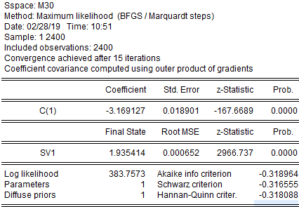

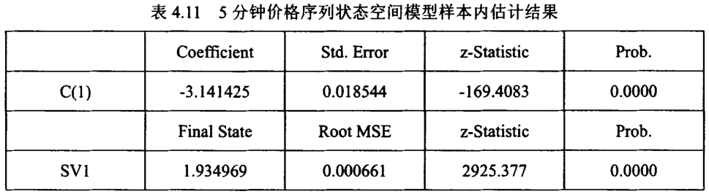

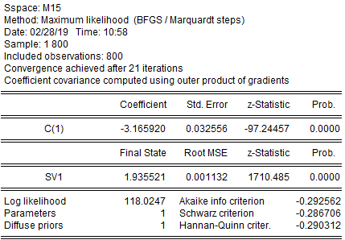

文献结果

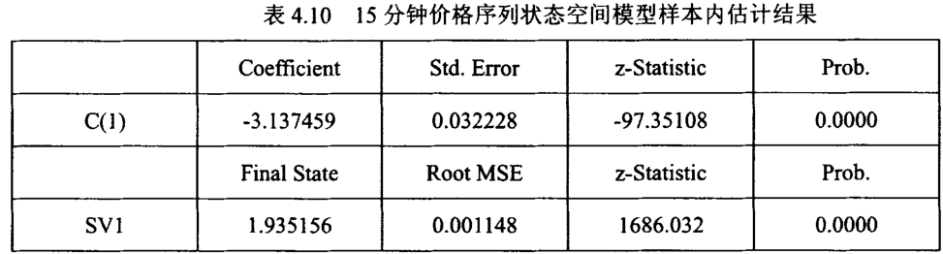

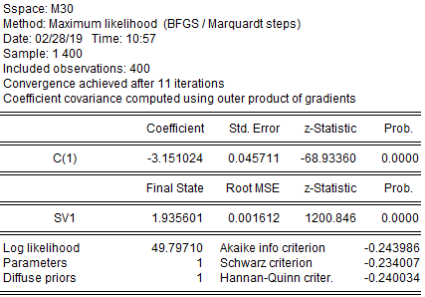

文献结果

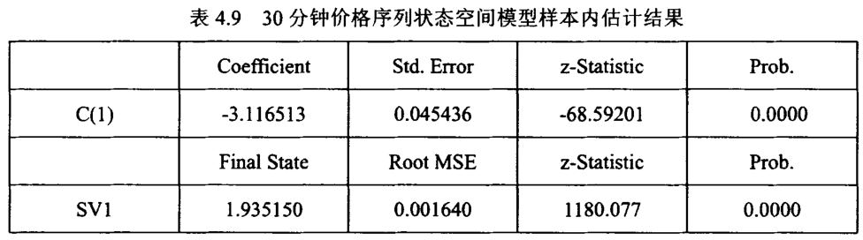

5 回测比对